**Holiday Express Hotel Kampala**

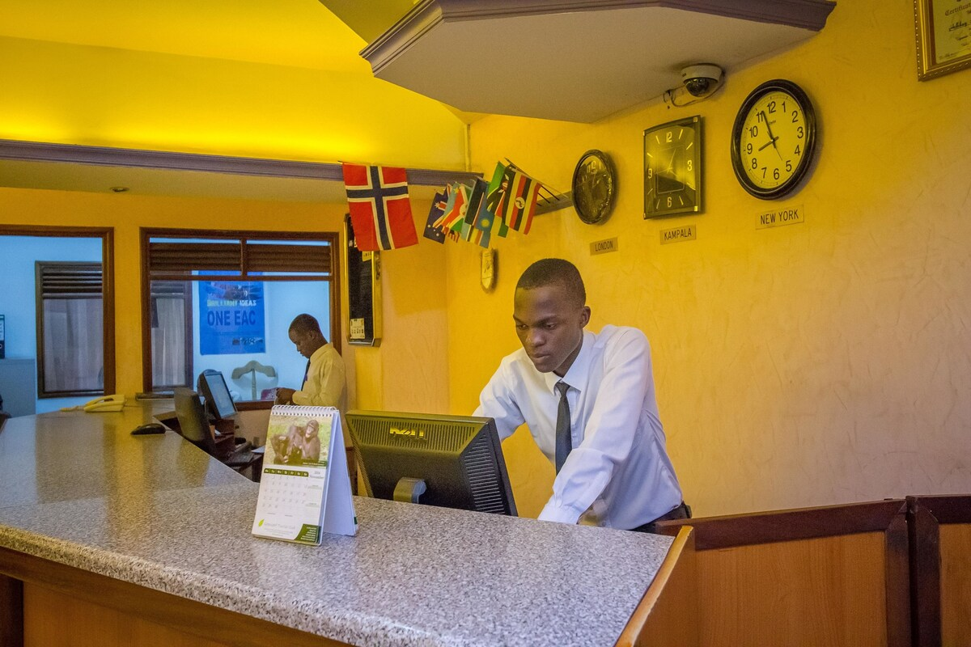

Set in a bustling area with shops and modest eateries, Holiday Express Hotel Kampala offers 3-star hotel accommodation in Kampala, 328 feet from Central Market (Uganda’s biggest fresh fruit market), 3 km from Kabaka's Palace and 4 km from the Uganda Museum.

Among the guest facilities of this downtown Kampala property are a restaurant & restaurant, meeting and event spaces, room service and a 24-hour front desk, along with free WiFi internet.

Down-to-earth rooms feature flat screen TVs, Wi-Fi and air conditioned, wardrobe, plus en suite bathrooms. Room service is available 24/7 and each room includes bed linen and towels.

Entebbe International Airport is 41 km away from Holiday Express Hotel. Airport transfers, superb breakfast and parking are available.

Popular points of interest near the accommodation include Owino Market/Kampala, 19 minutes on foot from Gaddafi National Mosque and Kasubi Royal Tombs (5.4 km).

**HOTEL SERVICES & FACILITIES**

• Accommodation

• 24/7 Front desk

• Daily housekeeping

• Bar, Restaurant & Rooftop

• Shared lounge

• Welcome drink

• Free parking

• Free Wi-Fi Internet

• Non-smoking rooms

• Laundry and Dry Cleaning Service

• Doctor services on call

• Secretarial Services on request

• Print, Scan, Mail and Photocopy facilities

• Conference facilities

• Travel and Information Desk

• Non-smoking rooms

• Baby cots on request

• Room Service from 11.00 – 22.00

• Shuttle Service

• Superb breakfast

• Backup generator

• Free parking available at the hotel

**GUEST ROOM INFORMATION**

**ROOMS: Total number of rooms 109 | 170 beds**

• 49 Deluxe Single / Double Room

• 56 Deluxe Twin Room

• 04 Triple Room

• 13 Basic Rooms

**Facilities in the rooms**

• Desk

• Complimentary bottle of water

• Tiled floor in all rooms

• Wardrobe

• Bathroom with shower in all rooms

• Flat-screen TV

• Satellite Channels

• Air conditioning

• Fan

• Electric Plug (220/110V)

• Telephone

• Wireless Internet throughout hotel

• Wake-up service

• Towels & Linen

**In your private bathroom:**

• Toilet

• Shower with warm & cold water

• Slippers

• Toilet paper

• Body soap, shampoo, shower gel

**RESTAURANT**

Holiday Express Hotel has a restaurant and a bar. Located on the first floor of the property, the restaurant has a sitting capacity of 100 people and serves savoys local and international dishes.

Restaurant open all day. You can see the restaurant menu card on our website.

• Breakfast 6:45 a.m. – 10 a.m.

• Lunchtime 11:30 a.m. – 3 p.m.

• Dinner Time 6.30 p.m. – 10 p.m.

• Takeaway 6:30 a.m. – 9 p.m.

• Room service 12 p.m. – 9.30 p.m.

**BAR**

We have two well stocked bars that open 14:00 till midnight.

Tervan Bar offers the best downtown cocktail bar experience with handmade cocktails, shareable drinks, beer & wine from flair bartenders. You can see the bar menu card on our website.

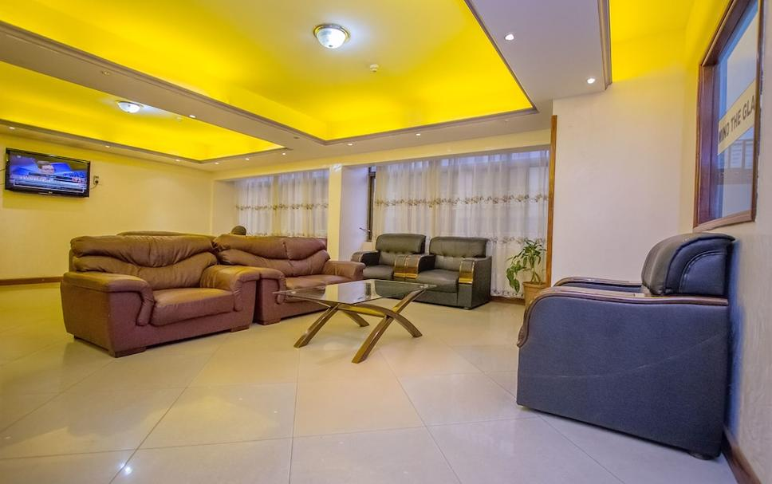

**MEETING & EVENTS FACILITIES**Due to our central location and easy access to major city roads and offices, Holiday Express Hotel is a favorite choice for conference, meetings and events venue in Kampala.

In return the hotel has invested greatly in improving the facilities needed to make these functions successful, resourceful and fun

The hotel has three conference halls with capacities of 50, 80 and 200 sitting capacity.

Other services include in house catering to a maximum of 200 guests and outside catering to maximum of 500 people

Our roof top bar has capacity of 150 for cocktails and parties

Our conference and meeting rooms are perfect for hosting large groups, as well as break-away areas for smaller meetings and brainstorms.

**Conference / Meeting Rooms**

|  |  |
| --- | --- |
| Hall / Venue Name | Capacity (Pax) |
| Eland Hall | 50 - 70 |
| Zebra Hall | 80 -100 |
| Jumbo | 150-200 |

**Conference Services / Facilities**

• Mid-Morning & Afternoon Coffee/Tea/Juice and bites

• Buffet lunch or dinner with soft drink

• Session water

• LCD projector

• White boards

• Video monitors

• PA System

• Secretarial services

• Internet access

• Fax services

• Mints

• Flip Chart & Pens

• White Board & Pens

• Linen

• Service Staff

• Tables & Chairs

Setup & Clean up

**Conferencing Packages:** Kindly contact us via E-Mail for a formal quote and further detail and Menu options for our venue prices for conferences and team buildings

**Teambuilding venue:**

Holiday Express Hotel offers one of the most affordable and best locations in downtown Kampala area for corporate team building in Kampala.

Our conference and team-building clients range from top companies and organisations to small businesses who loves our teambuilding venue as it suits their needs and go beyond everyone's expectations for teambuilding activities.

For pricing on teambuilding venue hire and other details, contact us via email or phone us.

**Indoor & Outdoor Wedding Venue Options in Kampala**

Holiday Express Hotel Kampala offers the perfect indoor and outdoor wedding venue in Kampala. Choose from our hall selection sitting upto 200 guest or our rooftop space. For pricing on wedding venue hire and other details, contact us via email or phone us today.

**Languages spoken:** English, Luganda, Swahili, Runyakitara

**PAYMENTS:** We accept both cash and valid, major credit and/or debit cards, Mobile money as deposit upon check-in.

**SHUTTLE SERVICES**

Guided tours to various tourist destination centers around the country, airport pickups, airport drops, and travel and car hire services are available upon request

Simply reach out to our concierge department a shuttle of your choice will be arranged accordingly

You will also be guided on small tours around the country at with a wide tourism sites around Kampala

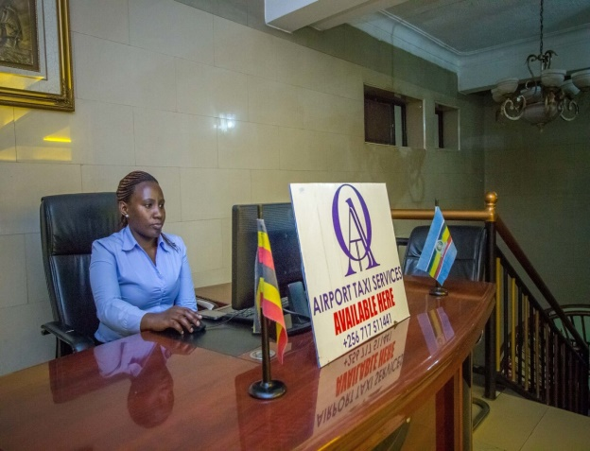

Conferences

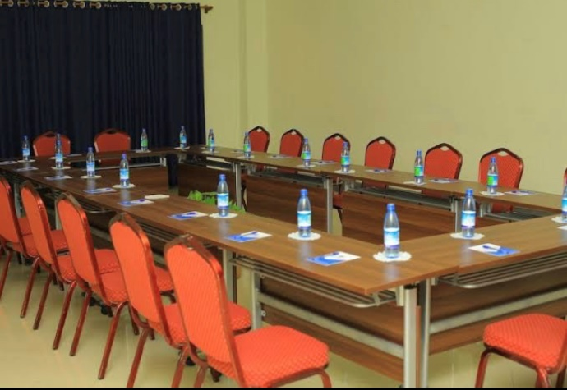

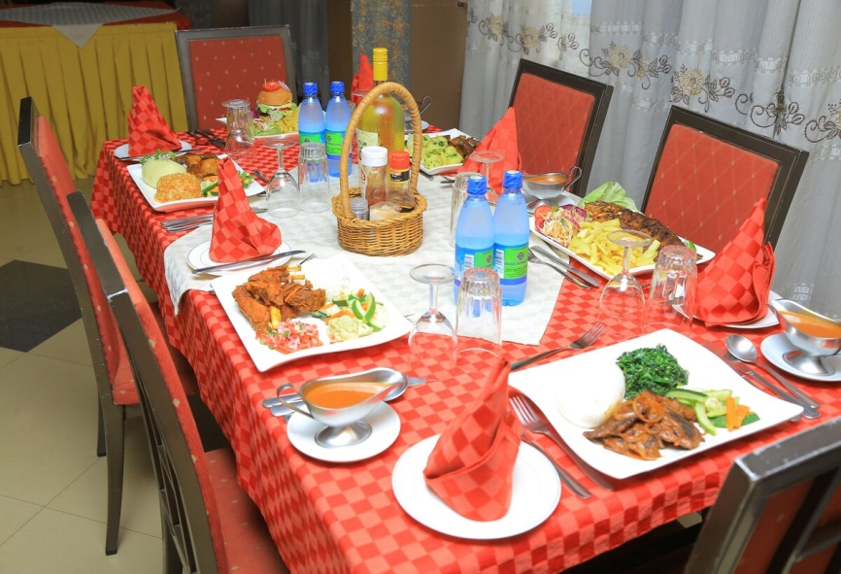

Weddings and events

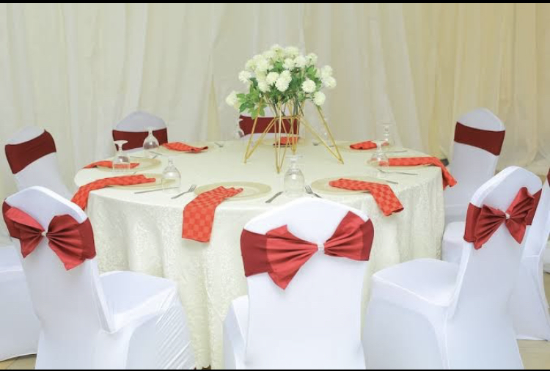

**TOP ATTRACTIONS AND THINGS TO DO IN KAMPALA**

Kampala is Uganda's national and commercial capital bordering Lake Victoria, Africa's largest lake. Hills covered with red-tile villas and trees surround an urban centre of contemporary skyscrapers. In this downtown area, the Uganda Museum explores the country's tribal heritage through an extensive collection of artefacts. On nearby Mengo Hill is Lubiri Palace, the former seat of the Buganda Kingdom.

Below you will find some of the top attractions in Kampala and things to do in Kampala

* Nakasero Market
* Owino Market
* Kampala Taxi Park
* Rubaga-Kathedrale
* Gaddafi National Mosque
* Namirembe Kathedrale
* Baha'i Temple
* Ndere Cultural Centre
* Uganda Crafts 2000
* Uganda Martyrs Shrine
* Uganda Museum
* Kabaka's Palace
* The Acacia Mall
* Lake Victoria Cruise
* Independence Monument
* Cooking Class for Typical Ugandan Food
* Boda boda Tour
* Kampala City walking tour
* Golf at Kampala Golf Club
* Fishing at Laker Victoria
* Kabaka’s lake tour

Guided tours, travel and car hire services are available on request through the front desk.